**Bugs Report**

**(Bug 1)**

**Title of Bug:** Championship title does not update when filtering by any championship with matches on a selected date in the **"المباريات"** tab.

**Severity:** low **Priority:** medium

**Repro Steps:**

1. Open the **YallaKora** application.
2. Go to the **"المباريات"** tab.
3. Set the date to **الأحد 16 نوفمبر**.
4. Tap the page title **"كل المباريات"** to open the championship filter list.
5. Select any championship (e.g., **تصفيات كأس العالم - أفريقيا**).

**Expected result:** The page title should update to the selected championship name (e.g., **تصفيات كأس العالم - أفريقيا**).

**Actual result:** The page title does not change and remains **"كل المباريات"**.

**Attachment:**

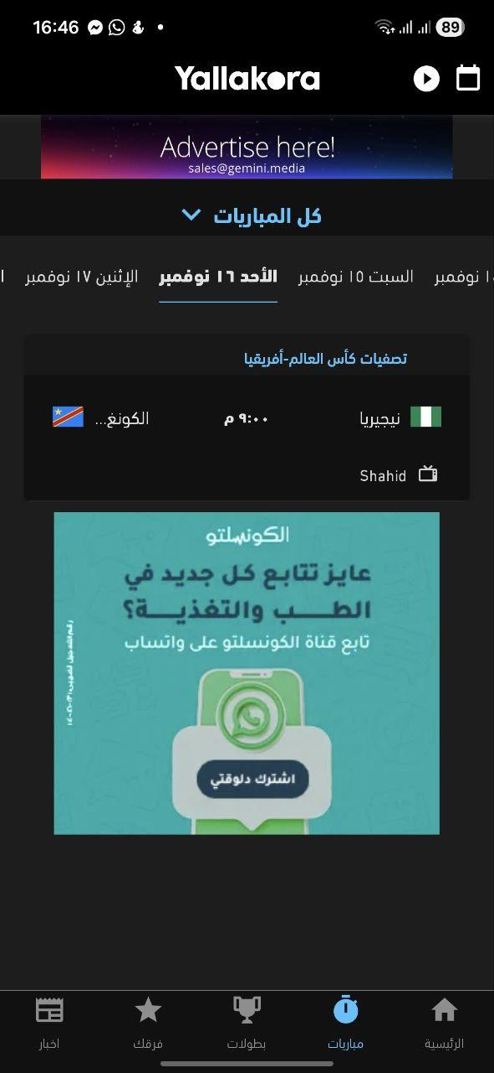

**(Bug 2)**

**Title of Bug:** Unable to clear the championship filter to display all matches for the selected date in the **"المباريات"** tab.

**Severity:** medium **Priority:** medium

**Repro Steps:**

1. Open the **YallaKora** app, then navigate to the **"مباريات"** tab.
2. Set the date to **الأحد 16 نوفمبر**.
3. Tap **"كل المباريات"** and apply a filter by selecting any championship (e.g., **تصفيات كأس العالم - أفريقيا**).
4. Tap **"كل المباريات"** again to try to clear the filter.

**Expected result:** All championships and all matches for the selected date should be displayed.

**Actual result:** The filter cannot be cleared, and the app continues to display only the selected championship and its matches.

**Attachment:**

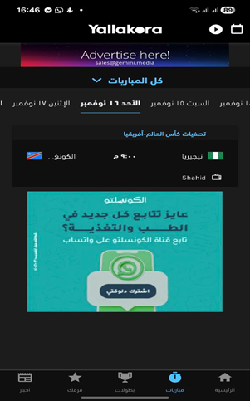

**(Bug 3)**

**Title of Bug:** No data is returned when re-selecting the same date to reload the latest data in the **"المباريات"** tab.

**Severity:** high  **Priority:** high

**Repro Steps:**

1. Open the **YallaKora** app, then go to the **"مباريات"** tab.
2. Select any date (e.g., **today**).
3. Re-select the same date again to refresh or update the data.

**Expected result:** All championships and all matches for the selected date should appear, with updated results and data.

**Actual result:** A loading indicator appears, but no data is returned.

**Attachment:**

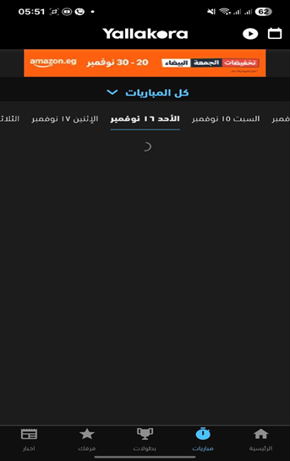

**(Bug 4)**

**Title of Bug:** No data is displayed in the **"التشكيل"** tab in match details, even though team lineups exist in the **"دقيقة بدقيقة"** tab.

**Severity:** medium  **Priority:** medium

**Repro Steps:**

1. Open the **YallaKora** app.
2. Tap any live or finished match to open its details.
3. Tap the **"التشكيل"** tab to view the team lineups.

**Expected result:** The team lineups should be displayed in the **"التشكيل"** tab.

**Actual result:** No data is displayed in the **"التشكيل"** tab, despite the lineups being available in the **"دقيقة بدقيقة"** tab.

**Attachments:**

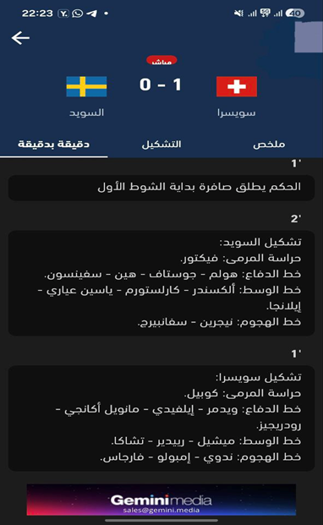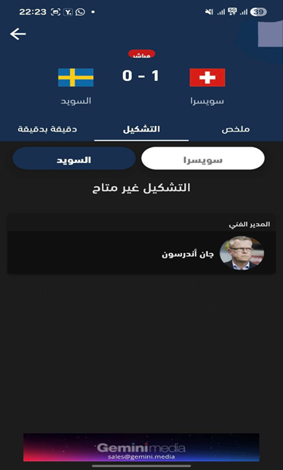

**(Bug 5)**

**Title of Bug:** No data is displayed in the **"الاحصائيات"** section within the **"ملخص"** tab in match details.

**Severity:** medium  **Priority:** medium

**Repro Steps:**

1. Open the **YallaKora** app.
2. Tap any finished match to open its details.
3. Tap the **"ملخص"** tab to view important moments and match statistics.

**Expected result:** The match statistics should be displayed in the **"الاحصائيات"** section.

**Actual result:** No data is displayed, and no message is shown indicating that statistics are unavailable.

**Attachments:**

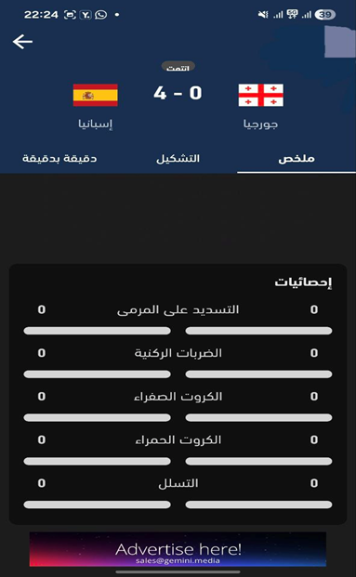

**(Bug 6)**

**Title of Bug:** Some championship icons are not displayed in the **"البطولات"** tab.

**Severity:** low  **Priority:** medium

**Repro Steps:**

1. Open the **YallaKora** app.
2. Navigate to the **"البطولات"** tab.

**Expected result:** All available championships should be displayed with their corresponding icons.

**Actual result:** Some championship icons are missing and not displayed.

**Attachment:**

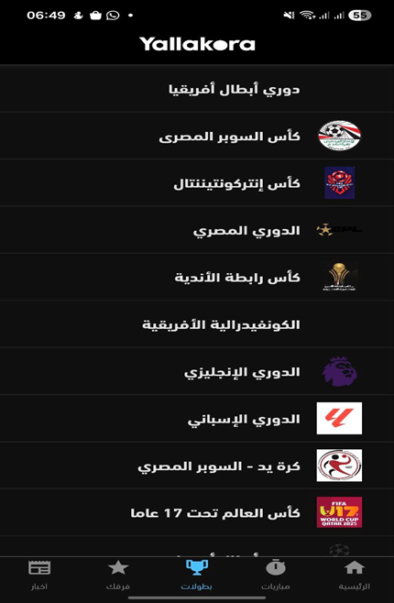

**(Bug 7)**

**Title of Bug:** Search bar in **"فرقك"** tab only searches competitions when tabs are collapsed, not teams, despite placeholder suggesting team search.

**Severity:** low  **Priority:** high

**Repro Steps:**

1. Open the **YallaKora** app.
2. Navigate to the **"فرقك"** tab.
3. Observe the search bar placeholder, which indicates you can search for a team or national team.
4. Leave all competition tabs collapsed and enter a team name in the search bar (e.g., **مصر**).

**Expected result:** Teams should be searchable even when competition tabs are collapsed, it should show Egypt’s national team.

**Actual result:** Search only matches competitions as teams are found only after expanding the relevant tab.

**Attachment:**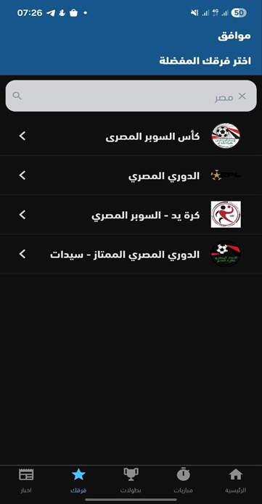

**(Bug 8)**

**Title of Bug:** No action occurs when pressing the share button for any news article in the **"الأخبار"** tab.

**Severity:** high  **Priority:** low

**Repro Steps:**

1. Open the **YallaKora** app.
2. Go to the **"الأخبار"** tab and open any news article.
3. Press the share button to share the article.

**Expected result:** The share window should appear, allowing sharing via apps or copying the link.

**Actual result:** Nothing happens when pressing the share button.

**(Bug 9)**

**Title of Bug:** Championship live statistics and matches are shown in a team’s details even after the team is eliminated.

**Severity:** high  **Priority:** low

**Repro Steps:**

1. Open the **YallaKora** app.
2. Go to the **"بطولات"** tab and select any championship (e.g., **دوري أبطال أفريقيا**).
3. Go to the **"المباريات"** tab and select a match involving a team that is already out of the championship (e.g., **الأهلي vs أيجل نوار**).
4. Tap **"أيجل نوار"** to view its details.

**Expected result:** A message should indicate that the team is eliminated and no matches are available.

**Actual result:** The current stage table is shown, with no indication of the team’s eliminated status.

**Attachment:**

**(Bug 10)**

**Title of Bug:** Match results on the general live matches page are delayed, even though updated in match details.

**Severity:** medium  **Priority:** high

**Repro Steps:**

1. Open the **YallaKora** app.
2. Go to the **"مباريات"** tab and view live matches.
3. Wait until a specific match result changes, then check the general live matches page.

**Expected result:** The updated result should appear immediately on the general live matches page.

**Actual result:** The general page does not update, while the match details show the correct result.

**Attachment:**